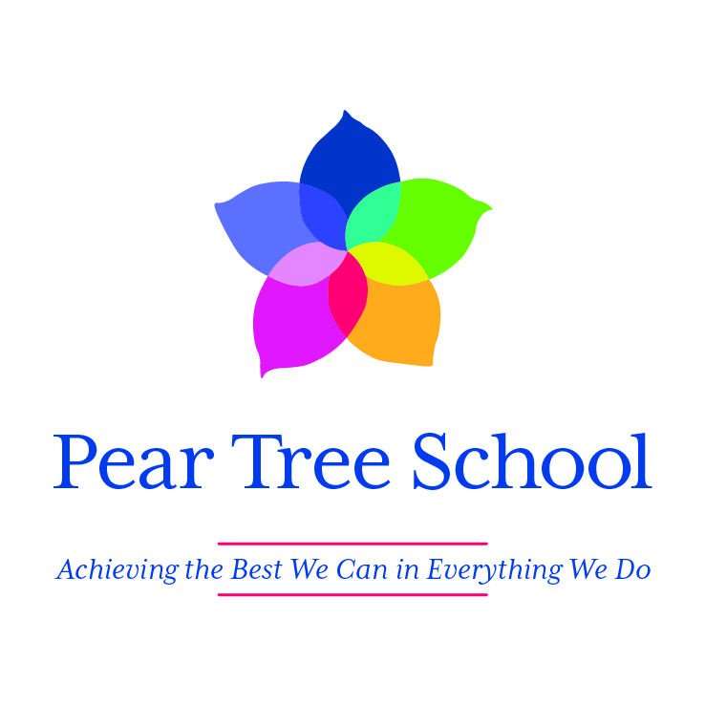

Newsletter

Summer 2 2023

In this newsletter

. Annual reports

. Ofsted

. So long! Farwell!!

. Wedding Bells

. Annual Family Disco

. Creative curriculum

. Holiday List 2023-2024

What a year this has been at Pear Tree and when I look back at the year, I am so proud of what we have all achieved. We have had more families than ever joining us for different events including Open afternoons and mornings, transition discussions, assembly, performances, training, Parents Evening and Open Evening. I look forward to increasing these opportunities over the next year too. One area I would like to involve more parents in is our PTFA who work incredibly hard, but are in need of more parents to join them. In the autumn term, we will send out invites to the next PTFA meeting and hopefully some of you will be able to attend as I know they have lots of ideas to not only fundraise for school, but also ways in which parents can come together for more social gatherings.

Pear Tree is now completely full for the next academic year and we all look forward to another year of achievements. I recognise that for many parents, the summer holidays can be a challenging time and if you would like any resources sending home to support the pupils keeping to some sort of routine, then please just ask the class teacher.

I have been so proud of our school and the children and staff this year and thank you all so much for your continued support.

With the warmest of wishes

Kate



Annual Reports

You should have all by now have received your son/daughter’s Annual Report sent via Evidence for Learning. If you have had any problems accessing this then please contact the school office. The teachers and supporting staff have worked very hard to put together this learning journey with you and I have enjoyed reading each report and seeing the amazing achievements of all of our children.



Ofsted

I would have hoped to have been able to share with you our most recent Ofsted report before the end of term, but this now seems highly unlikely due to time constraints from Ofsted. I would like to say a massive thank you to all parents who contributed in any way during the inspection by either completing the parent/carer survey or by speaking to the inspector. It was a very positive experience for the school and I can’t wait to share the report with you all in the autumn term.

So long! Farewell!

It is always a very bittersweet time of year as we have to say our goodbyes to some of our amazing pupils. Brandon, Ellie, Joshua, Jacob and Kirsty will all be leaving Pear Tree at the end of the term. They have each got an exciting pathway into adulthood and we are all so proud of their many achievements. They have each been huge personalities across the school and Compass Centre and we are delighted by all of their individual achievements.

Zarda Khan our family worker will also be leaving at the end of the year. I know Zarda has provided a lot of support this year to many of our families and I want to reassure you all that we have already employed Rachel Keighley to take over in this role. Rachel will be in touch with those families currently supported by Zarda in the Autumn term to introduce herself.



Wedding Bells

We have two Pear Tree weddings to celebrate this summer. Alice (Early Years) and Michelle T (Pine Tree) are both getting married and we would all like to wish them congratulations.



Annual Family Disco

We were so upset to have to cancel our family disco at Ribby Hall. In previous years we have had to turn people away due to it being so popular and this year, due to a number of reasons, we were unable to make it to the minimum number required. Parents have previously commented that this is the one event they attend where they can relax and enjoy an occasion with their family without the worry of other people around them. Therefore, we will be holding the disco on October 18th at the earlier time of 5pm – 8pm in an attempt to get more families with younger children able to attend.

More information will be sent out in September and I hope you will all be able to join us.



Creative Curriculum

This term’s creative curriculum theme is ‘Living in a multi-sensory world’ has allowed our students to engage in the world around through sight, smell, taste, touch and hearing. The inspiration day focused on the senses and various activities in the hall and the sensory room. The sensory room glowed with UV, exploring textures of paint and sand alongside classical music whilst the hall allowed students to be explorers, trying to guess the object by their textures, identify items which were magnified and a big favourite was the food and taste station!

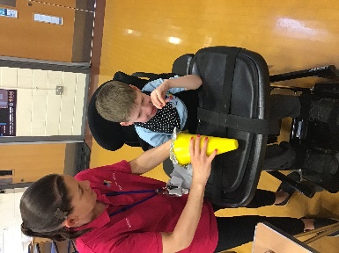 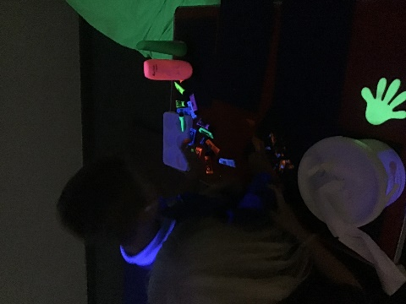

Throughout the term, classes have incorporated living in a multi-sensory world when delivering topics including Attention Autism, engaging all the students’ senses to develop their inquisitive skills in all stages. One class has been using their class text “The extraordinary life of Greta Thunberg” to bring alive weather and temperatures, getting the students to experience various types of weather and what that means to all the senses and learning the Makaton signs. Throughout the term the students have been focusing on using observational and touch skills to work in a multi-sensory world and the students have worked hard in engaging in sessions using all their senses (and at times getting messy!)

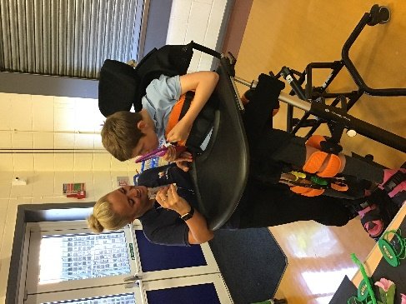



#### Holiday list 2023 - 2024

**Autumn Term**

Open Monday 4th September 2023

Close (Half Term) Friday 20th October 2023

Open Monday 30th October 2023

Close Friday 22nd December 2023

**Spring Term**

Open Monday 8th January 2024

Close (Half Term) Friday 9th February 2024

Open Monday 19th February 2024

Close Thursday 28th March 2024

**Summer Term**

Open Monday 15th April 2024

May Day Closure Monday 6th May 2024

Close (Half Term) Friday 24th May 2024

Open Thursday 6th June 2024

Close Friday 19th July 2024

**Staff Inset Days**

**Friday 1st September 2023**

**Monday 3rd June 2024**

**Tuesday 4th June 2024**

**Wednesday 5th June 2024**

**Monday 22nd July 2024**